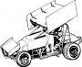

3501 S. Sheridan

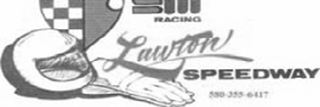

Lawton, OK 73505

580-355-6417 [www.lawtonspeedway.com](http://www.lawtonspeedway.com/) [Email:lawtonspeedway@yahoo.com](mailto:lawtonspeedway@yahoo.com)

2014

CHAMP SPRINT DIVISION RULES

IF it doesn’t say that you can do it, YOU CANNOT!!!!!!!!

1. GENERAL

The Champ Sprint Division is an intermediate class for super sprint division racecars. It is the intent that all cars/drivers will advance to the super sprint competition with very few modifications to the car. Since this is an intermediate class, the investment required is NOT commensurate with the prize money and races may be cut or shortened because of excessive delays, etc.

2. BODY COMPONENTS

The definition of an upright car is a conventional front mount engine in which the vertical

position is to be maintained as closely as possible, with a maximum half inch offset. The driver shall be seated directly behind the engine, the fuel tank must be behind the driver and the radiator must be positioned in front of the engine. The driver cannot be located beside the drive shaft. Side lips on hoods cannot exceed 2 ½ “. Nerf bars cannot be attached to car in more than three places, no gussets. May not exceed .120 wall

thickness and no larger than 1 inch od. Maximum width: 36” left, 42” right, measured from center of driveline.

3. CHASSIS AND ROLL CAGE

MUST BE CONSTRUCTED of steel channel or tubing of a 1 3/8” minimum outside

diameter by .095 inch wall thickness for the main rails and cage. Specially constructed front engine rear wheel driven racecars of sprint car design. NO aluminum frames or roll cages.

4. WHEELBASE

Minimum 84” , maximum 102” measured from center of the front hub to center of the rear

hub.

5. WEIGHT

Weight minimum 1,500 pounds, including driver. Cars may be weighed at any time. Fluids

used or parts lost during a race may not be added to make weight. NO TOLERANCE. Add-on weights must be bolted with a minimum of two (2) 3/8” bolts and double nutted and or/ weight clamps. Weights must also be painted white with car numbers present.

2009 Champ Sprint Rules—Page 1 of 5 Rev 01/28/09 / Verified 01/28/09

6. WINGS

Wings maximum size shall be 16 sq. ft. on the top horizontal section, 60" maximum width.

The maximum size of vertical side panels shall be no more than 10 sq. ft., including the lip on top and bottom of side panels. No flaps or rudders may be attached to sideboards or center section. Wicker Bill on the top lip of the center section can be no more than 1” MAX. Wing cannot exceed 2 ½” drop in belly of wing. The maximum size of nose wings shall be 2' x 3'. NO wicker bill of any sort will be allowed on the nose wing. No hydraulic, mechanical or electrical device may be used that will enable the driver to adjust the

wings from inside the car while driving the car. Nerf bars may not be covered so as to give the effect of a wing.

7. TIRES / WHEELS

Right rear –AMERICAN racer 102/16.0-15 Medium or Hard or Hoosier 105/16.0-15

medium or a Hoosier RC3. All tires must durometer within 5 points of factory specs. Left rear can be no wider than 18 1/2” cross section, this will be measured using a Hoop.

3.09 Insert type foam-rubber wheel covers, or covers that are securely fastened to the

wheels, are the only style wheel covers that are acceptable. WHEEL TYPE is optional. Bead locks are optional

8. FUEL CELLS

Fuel cells and bladders mandatory. A fuel shut-off valve within easy reach of the driver

required. NO vinyl or plastic fuel lines allowed. Fuel cell must be securely mounted. If cable operated valve is used, pull lever must be mounted behind driver's head on roll cage, upright facing the left side of car. The handle should be painted red for easy

identification by track officials. NO car can start a race with more than 40 gallons of fuel.

9. SHOCKS

No adjustable shocks that can be controlled from inside the car.

10. DRIVELINES

All drivelines must be broken in the coupler or rear slider. Torque arm drivelines may not

be used. All drivelines must be enclosed and contain no more than one U-joint or C-V joint, and that one must be at the front of the driveline. A drive shaft loop or restraint is mandatory.

11. ENGINE

Any V-8 cast iron automotive engine block. No ALUMINUM

A. Maximum displacement 368CI

B. Brodix OKC spec head or any cast iron cylinder head that is manufactured by the manufacture of the engine used, no aftermarket heads such as DART etc may

be used. Cast iron heads may be ported and polished. Valve angles are to remain

as manufactured. NO moving or offsetting of dowels in block or head. Combustion chamber can be re-shaped. No Coating of intake or exhaust runners. Coating of valves and combustion chamber is OK.

C. Domed pistons not allowed. Flat top pistons or stock type dished pistons ONLY.

D. An steel rod or crankshaft may be used. No titanium engine parts will be allowed except valve spring retainers.

E. Camshaft is optional, but NO overhead camshaft.

2009 Champ Sprint Rules—Page 3 of 5 Rev 01/28/09 / Verified 01/28/09

F. Intake Manifold: OEM or stock type cast aluminum allowed. May be ported only to match heads. One 1 3/4” (maximum) spacer or adapter may be used between carburetor and intake manifold. No welding, grinding, cutting, porting, polishing anywhere on intake EXEPT for one inch maximum inside intake runners to match heads.

G. Oil Pan: Only pan-type oil pumps allowed. Dry sump or external pumps are prohibited. H. Oil Pan Style is optional. A one-inch diameter inspection hole in the upper side of the pan above oil line and windage tray is recommended. IF car is protested or inspected and oil has no inspection hole, pan must be pulled at track.

I. All valves and plugholes must remain in stock location

J. Automatic cam timing devices are prohibited.

K. Water Pumps are limited to stock mount beltdriven type.

L. NO TRACTION DEVICES!

M. All cars must have minimum of two wheel hydraulic brakes in good working order, three to four wheel brakes recommended. No Carbon Fiber brake rotors or pads. Brakes will be tested throughout the year.

OKC ALUMINUM SPEC HEAD RULE:

1. All spec heads will be supplied with CNC bowl blend and intake matching.

2. No grinding or blending of CNC work is allowed.

3. No grinding or polishing of any kind is allowed anywhere on the castings.

4. No use of any substance that may change or alter the shape or size of ports or com bustion chambers is allowed.

5. Valve seats and guides are to remain as manufactured and in their cast position, valve must stay on valve seat and cannot touch aluminum.

6. Valve angles are to remain as manufactured. The original seat center Locations as provided by the head manufacturer may not be altered.

7. No tapering or reshaping of valve guides will be allowed.

8. No minimum combustion chamber volume.

9. Spec cylinder head serial numbers must remain on the head and may not be defaced or altered.

10. No welding modifications are allowed to the original castings. Brodix will provide a repair service where we register and keep track of repairs if you desire. (Chevrolet part number SP CH OKC) (Mopar part number SP MO OKC) (Ford part number SP FD OKC)

11. Valve stem may be no smaller than 11/32.

Note: A new cast head is being offered by Chevrolet, But is still unavailable for inspection.

This head part #25534371 is not legal at this time (until availability and inspection.).

12 CARBURETOR:

One (1) two(2) barrel Holley carburetor not to exceed 500 cfm. No solenoid. Carburetor will be

checked using a GO/NO GO gauge. Carburetor venturibore, throttle plate bore, throttle shaft diameter and booster size will be checked using GO/NO GO gauge. Measurements are as fol- lows: Venturiborne max 1.390”, throttle plate bore max 1.700”, throttle shaft diameter

min .180”, booster height size min. .435” booster size interior max of .385”, exterior booster max .6600”. The use of fuel injection, supercharger, turbo charger, nitrous oxide or water injec- tion will NOT be allowed. . Fuel pump type is optional. No pressurized fuel systems

13 IGNITION:

Any kind of ignition mechanically driven in stock position NO CRANK TRIGGERED IGNI-

TIONS. All crank triggered devices must be removed.

14. FUEL: Alcohol (methanol) or gasoline allowed. NO ADDITIVES OF ANY TYPE.

METHANOL FUEL CHECK

When methanol fuel is checked using water test procedures, and a racer’s fuel does not pass, the racer has two options:

1. Accept the fact that the methanol tested from the car failed and is not legal for use.

This will come with disqualification and may bring along other penalties.

2. A racer can submit $200.00 for a laboratory fuel test. The fee of $200.00 must be sub- mitted at the time of fuel check and must be in cash to the tech official. A fuel sample will be removed from the car in question at that time. Also, the racer that submits the

$200.00 to have this failed fuel checked, all results from the laboratory will be final. As rules state, all methanol must be pure, no additives of any kind. With this, it does not matter what substance is found in the methanol. If any is found, the racer will be advised by the track of the outcome of the fuel checked, and any penalties associated.

15. NUMBERS

Request your number from the Speedway office - (405) 948-6796. Drivers have priority on

numbers run in 2007, until April 17, 2008. Only two-digit numbers, NO three-digit numbers will be allowed. NO letters or symbols with letters. NO duplicate numbers. Paint numbers in contrasting colors on both sides of tail and wing and on nose wing. No Mylar or reflective type material may be used!!!! Numbers must be minimum 18” tall. Any other significant letter must be a minimum of 9” tall. Number must be confirmed by entry form. Numbers issued and not run in three consecutive race programs may be declared open

and re-issued. Make numbers BIG, NOT FANCY and kept clean, SCORERS

CANNOT SCORE THEM IF THEY CANNOT SEE THEM. NO SCORE - NO PAY! FOR FAN

INTEREST and identification the number "1" will be reserved for the 2007 division champion.

16. MUFFLERS

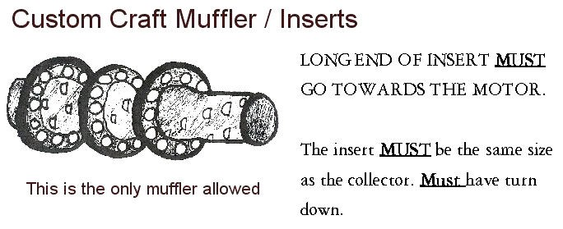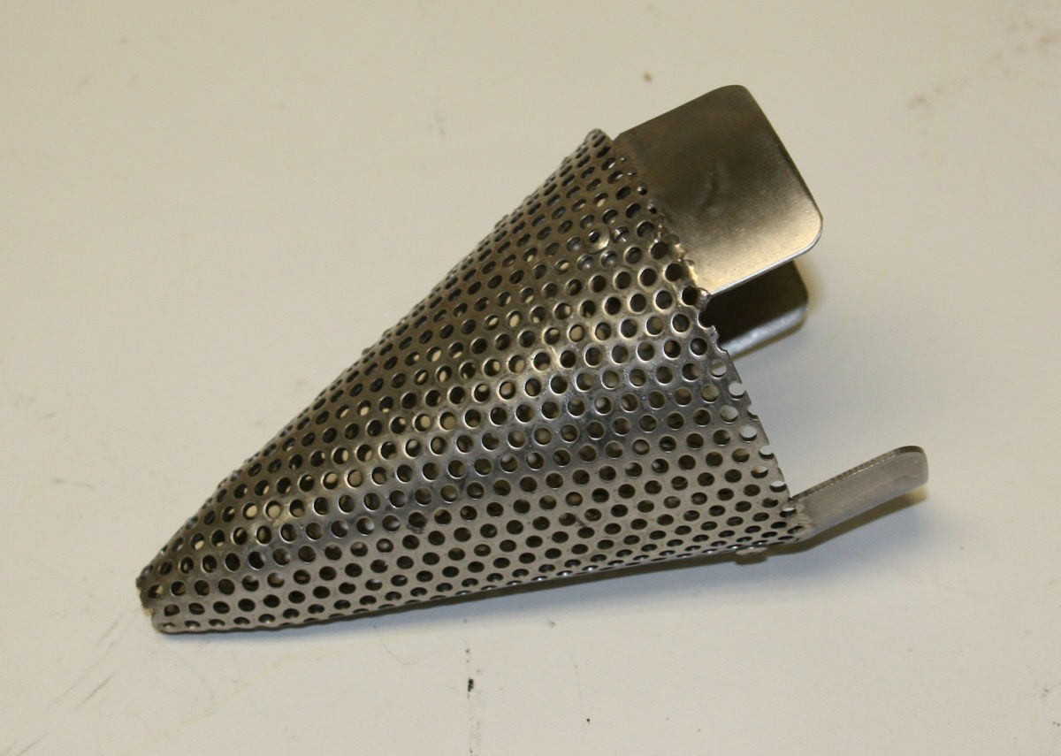

Custom Craft Muffler / Insert or Cone Muffler - 3 1/2 inch maximum

Cone Mufflers available at Smiley’s or at all

Speedway’s.

The cost will be - $35.00 each

17. GENERAL SAFETY REQUIREMENTS

The safety requirements for all car classes are repeated here to emphasize their importance.

A. All cars subject to inspection at any time and must be free of mechanical defects and be in safe racing condition.

B. Full face racing helmets meeting Snell 2000 standards required and must be worn at all times car is on track, and must accompany vehicle at time of inspection. (SA RECOM- MENDED)

C. Fire retardant uniform and fire resistant gloves, fire resistant shoes and arm restraints are mandatory.

D. Bucket seats are mandatory and must be factory manufactured. Seat must be properly in-

stalled and seat back rest cannot be moved back farther than roll cage rear main hoop. NO car will be permitted in competition unless seat is properly installed.

E. A 3" wide safety belt and shoulder harness with 2 belts over shoulders and a quick release type are required. Must have a minimum of one submarine strap. All belts must be securely fas- tened to frame or cage. Belt must be replaced every four years. Any belts dated prior to 2004

are out of date. Date tag or stamp is required.

F. Shock-resistant roll cage padding on all bars that driver’s head, legs and arms may contact with while strapped in seat. A padded functional headrest in line with center of driver’s head is mandatory. There must be a 2" minimum clearance between driver’s head (with helmet) and top of roll cage without padding. Head restraint on right side mandatory. Loops may be used and must have same tubing requirements as frame. These must be added in a safe manner.

G. Two throttle return springs and steel toe strap on throttle are mandatory.

H. Front rock screen from top of hood to top of front halo and from roll bar to roll bar is re- quired. Must be mounted securely. NO zip ties, etc. Maximum openings 2" x 4".

ALL RACER’S MUST HAVE A WORKING RECEIVER BEFORE ENTERING TRACK. IF YOU ARE HAVING PROBLEMS WITH YOUR RECEIVER, GO TO THE PIT STEWART AND WE CAN DO A RADIO CHECK. THERE ARE NO EX- CEPTIONS!!!

IF YOU HAVE QUESTIONS CALL THE SPEEDWAY OFFICE Lawton Speedway - 580-355-6417